Issue from Paul 3/14/16

**From:** SAM Support  
**Sent:** Monday, March 14, 2016 5:19 PM  
**To:** Freeman, Janine; Janzou, Steven  
**Cc:** Dobos, Aron  
**Subject:** Fw: IEC 61853 issue

Hi Janine and Steve,

Attempting to import the attached Suneye file causes both SAM 2015.6.30 and the pi version to crash. It looks different from the Obstructions/Elevations file we have in our test collection. Can one of you investigate further?

I did checked line endings, and they are crlf, so I don't think that's the problem.

Thanks,

Paul.

-----

Paul Gilman

Solar Advisor Model Technical Support

[solar.advisor.support@nrel.gov](mailto:solar.advisor.support@nrel.gov)

**From:** Raj, Taran <Taran.Raj@windlogics.com>  
**Sent:** Thursday, March 10, 2016 4:06 PM  
**To:** SAM Support  
**Subject:** RE: IEC 61853 issue

Sounds good. Happy to help Paul.

It my traditional fashion (and as my testing continues) I have a question for you.

I've been trying to upload the following ObstructionElevation.csv (from Solmetric SunEye and I get an "unhandled exception error" and the import fails. Thoughts?

-----Original Message-----  
From: SAM Support [mailto:SAM.Support@nrel.gov]   
Sent: Thursday, March 10, 2016 3:01 PM  
To: Raj, Taran  
Subject: Re: IEC 61853 issue

This is an EXTERNAL email. Exercise caution. DO NOT open attachments or click links from unknown senders or unexpected email!

________________________________

Hi Taran,

Thank you for sending the data -- it's very helpful for us to have such data for testing the model.

The numerical method that SAM uses to generate parameters for the single-diode model from the data is not converging with that particular data set. It looks like there is not a problem with the data, but rather with the algorithm. We are investigating and working to find a solution.

Best regards,

Paul.

-----

Paul Gilman

Solar Advisor Model Technical Support

[solar.advisor.support@nrel.gov](mailto:solar.advisor.support@nrel.gov)

________________________________________

From: Raj, Taran <[Taran.Raj@windlogics.com](mailto:Taran.Raj@windlogics.com)>

Sent: Thursday, March 10, 2016 1:36 PM

To: SAM Support

Subject: RE: IEC 61853 issue

Here you go Paul.

Taran

-----Original Message-----

From: SAM Support [<mailto:SAM.Support@nrel.gov>]

Sent: Thursday, March 10, 2016 12:55 PM

To: Raj, Taran

Subject: Re: IEC 61853 issue

This is an EXTERNAL email. Exercise caution. DO NOT open attachments or click links from unknown senders or unexpected email!

________________________________

Hi Taran,

Would you mind emailing me your module test data so we can investigate?

Thanks,

Paul.

-----

Paul Gilman

Solar Advisor Model Technical Support

[solar.advisor.support@nrel.gov<mailto:solar.advisor.support@nrel.gov](mailto:solar.advisor.support@nrel.gov%3cmailto:solar.advisor.support@nrel.gov)>

________________________________

From: Raj, Taran <[Taran.Raj@windlogics.com](mailto:Taran.Raj@windlogics.com)>

Sent: Wednesday, March 9, 2016 2:32 PM

To: SAM Support

Subject: IEC 61853 issue

Hi Paul,

I've been having some issues with the IEC 61853 Single Diode implementation in SAM. Unfortunately, I didn't see anything covering the issue in the forum. I'm hoping you have some ideas to perhaps resolve the issue,

To begin I tested SAM's CEC with user entered parameters against similar results in PVsyst and am in general seeing great agreement between the tools. Unfortunately there seems to be some divergence at higher tilt angles. I suspect this has something to do with the default IAM modifiers that the CEC model assumes and the AR coating that has a specific IAM which was input into PVsyst. Unfortunaly I am unable to test this theory since SAM doesn't separate the module losses into the Temperature, Irradiance and IAM buckets like PVsyst does. I therefore decided to test the IEC 61853 model to compare its performance to the PVsyst and the CEC models. However this isn't working. When I import the Module test data (from a DNV GL report) into SAM and click the Calculate parameters button, I see the result below and SAM crashes.

I'm not sure why this is happening. I was hoping you may have some guidance for me on what may be causing this crash.

[<cid:image001.jpg@01D17A10.80450F50>]

Regards,

Taran Raj, Resource Modeling Analyst | WindLogics | 651-556-4276 |

1021 Bandana Blvd E Suite 111 | St Paul MN 55108 | [Taran.Raj@windlogics.com<mailto:Taran.Raj@windlogics.com](mailto:Taran.Raj@windlogics.com%3cmailto:Taran.Raj@windlogics.com)>

 -------------

Compare file from Taran to that used in SAM in SAMnt\tests\Shading Files for Import folder (SAM file on left and file from Taran on right)

Different number of header rows and different number of columns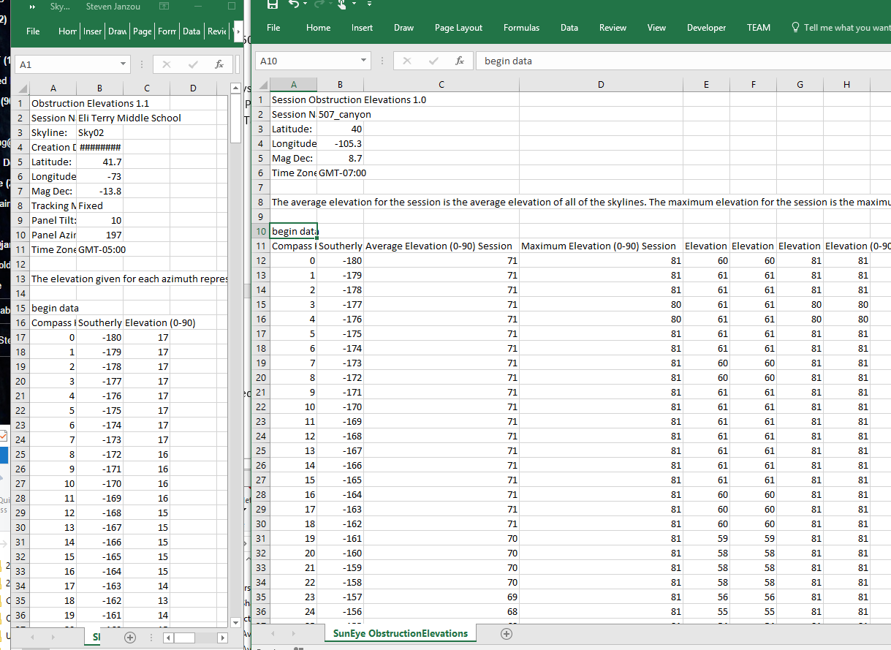

Step through in SAMnt debug version – trace to imageCount=-1 in ImportSunEyeObstructions function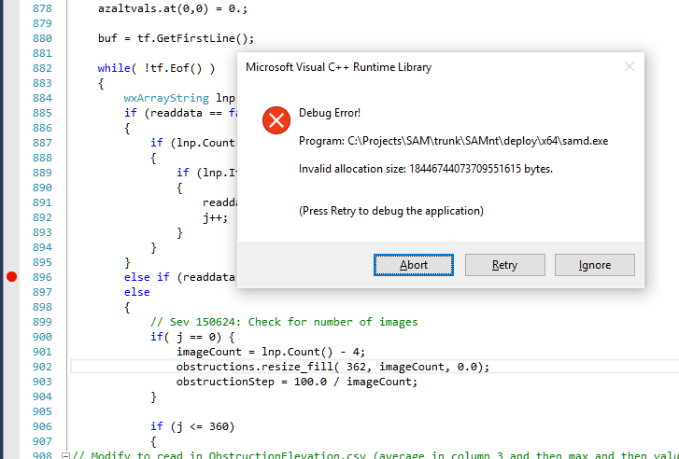

Fails when nc is negative – size_t value too large (nc in this case) 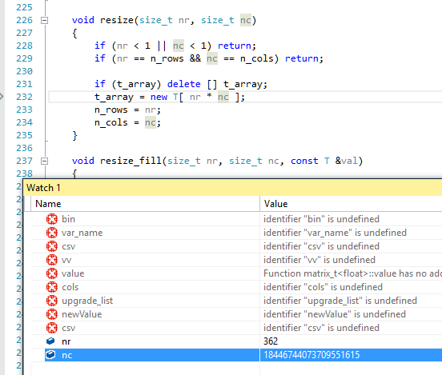

Update resize to not cause access violation when resizing to number of rows or columns less than zero: 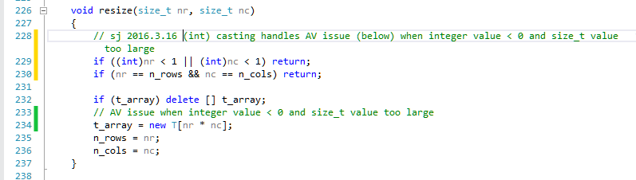

Build and test – no AV crash but nothing reported to user and all shading obstructions are zero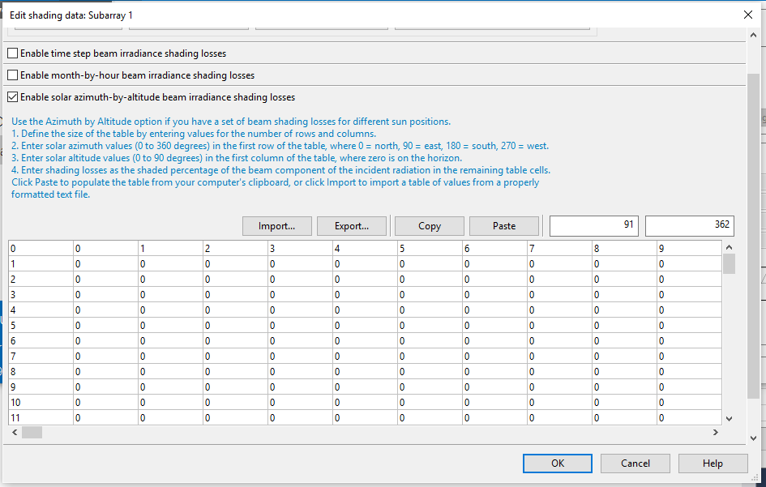

Update ImportSunEyeObstructions to handle no maximum and no average column (as per file from Taran) and to always have positive imageCount

The SAM test file works fine and Taran’s reads with no crash but returns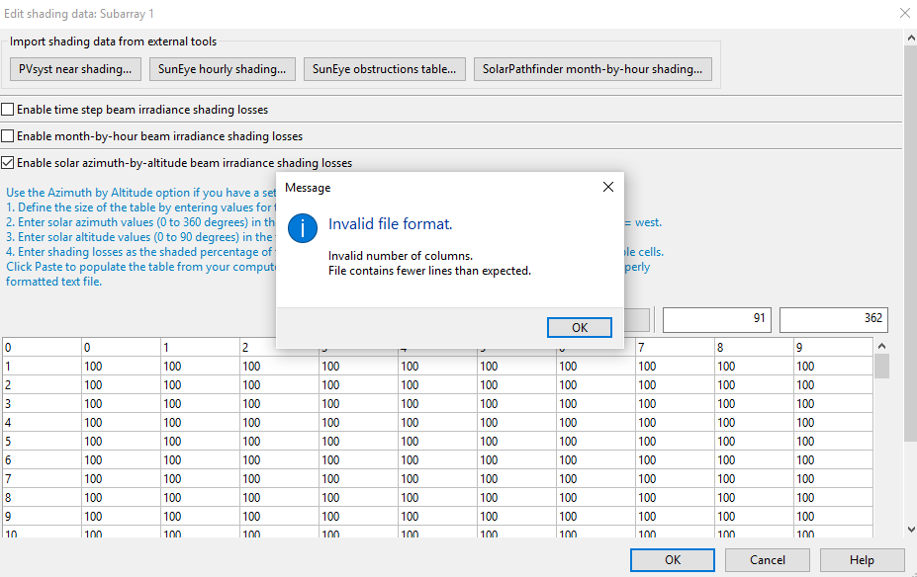

Remove unused alt data array and update error checking and find start and end of image data per 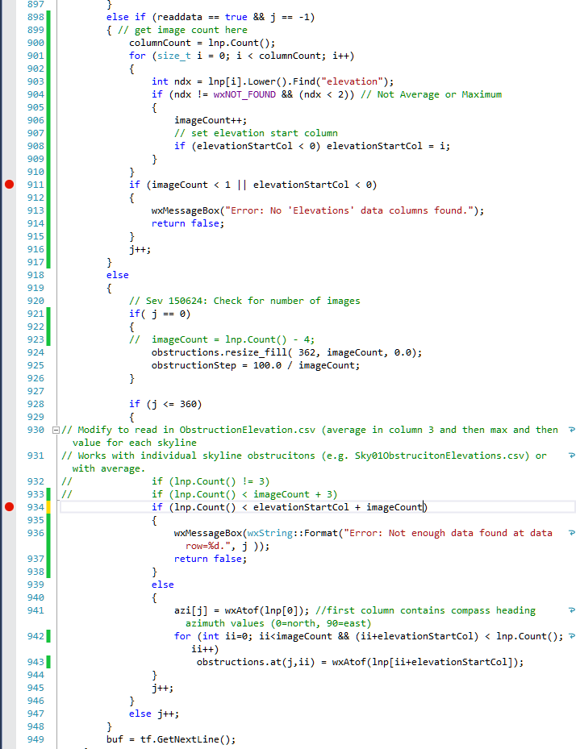

Test with both SAMnt obstruction file (SAMnt_SunEye ObstructionElevations.csv) and obstruction file from Taran (Sky02ObstructionElevations.csv) and verify start column for elevations and number of images:

Sky02ObstructionElevations.csv start=2, images=1

SAMnt_SunEye ObstructionElevations.csv start=4, images=4

And check that values applied.

Clean up code and check in SAMnt rev 2904.

Generate scripts and check differences – only 1 in “incorrect” read in in new version (on right side): 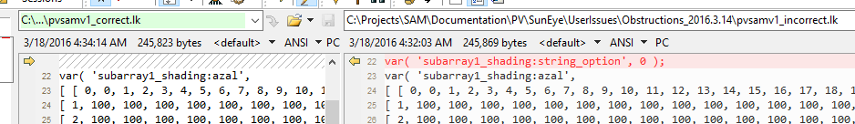

Run in SDKTool and look at annual output – dc value being loss and not accounted for properly

Matching with 2015.6.30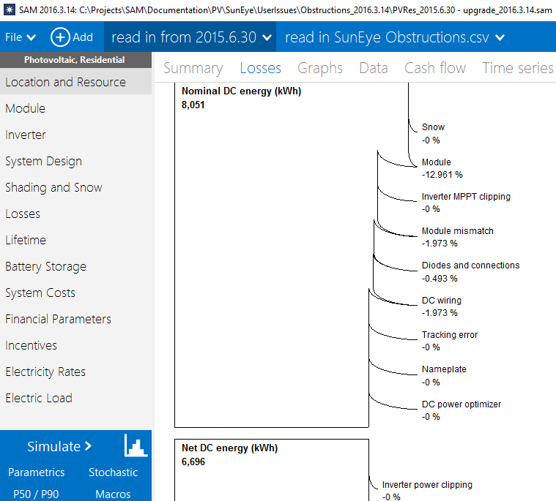

Incorrect (huge lost from nominal dc to net DC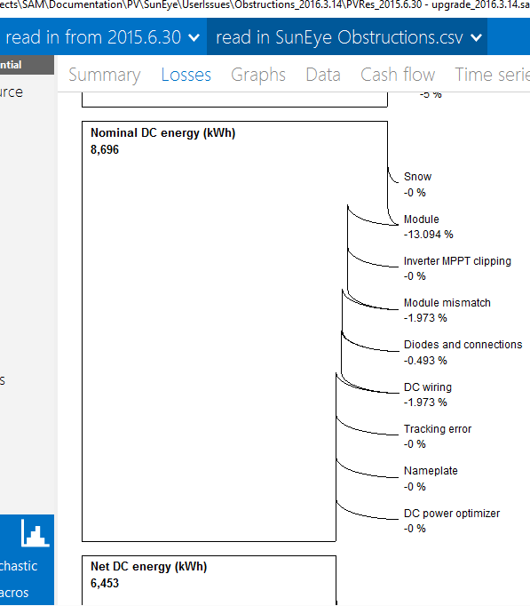

Run in SDKTool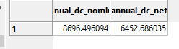

Remove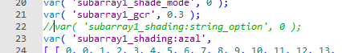

Run – issue in string_option setting in ShadingInputData::write and ShadingInputData::read – trace through and update load and save but never called and en_timestep never checked – so string option inproperly set to zero.

Update read and write and build and test and match with 2015.6.30 results but needs further testign for all configurations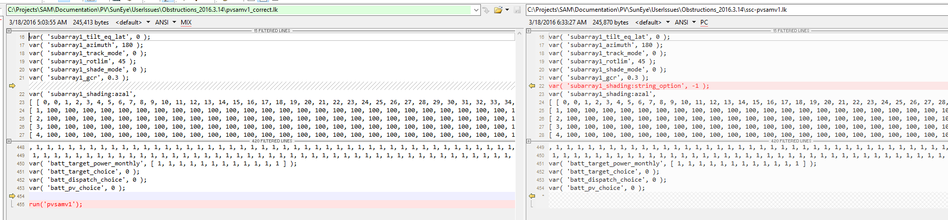

Check in trunk SAMnt rev 2919

Test SunEye shading files with 2015.6.30 release and 2016.3.14 release and with trunk version updates.

Obstructions file from Taran cause both 2015.6.30 and 2016.3.14 releases to crash. Trunk version runs and shading applied correctly.

Obstruction file from SAMnt test folder

6857 to 6355 kWh 2015.6.30 version 7.3% reduction

7482 to 6694 kWh 2016.3.14 version 10.5% reduction

7482 to 6938kWh trunk 7.3% reduction

With loss diagrams 2015.6.30 top, 2016.3.14 middle and trunk bottom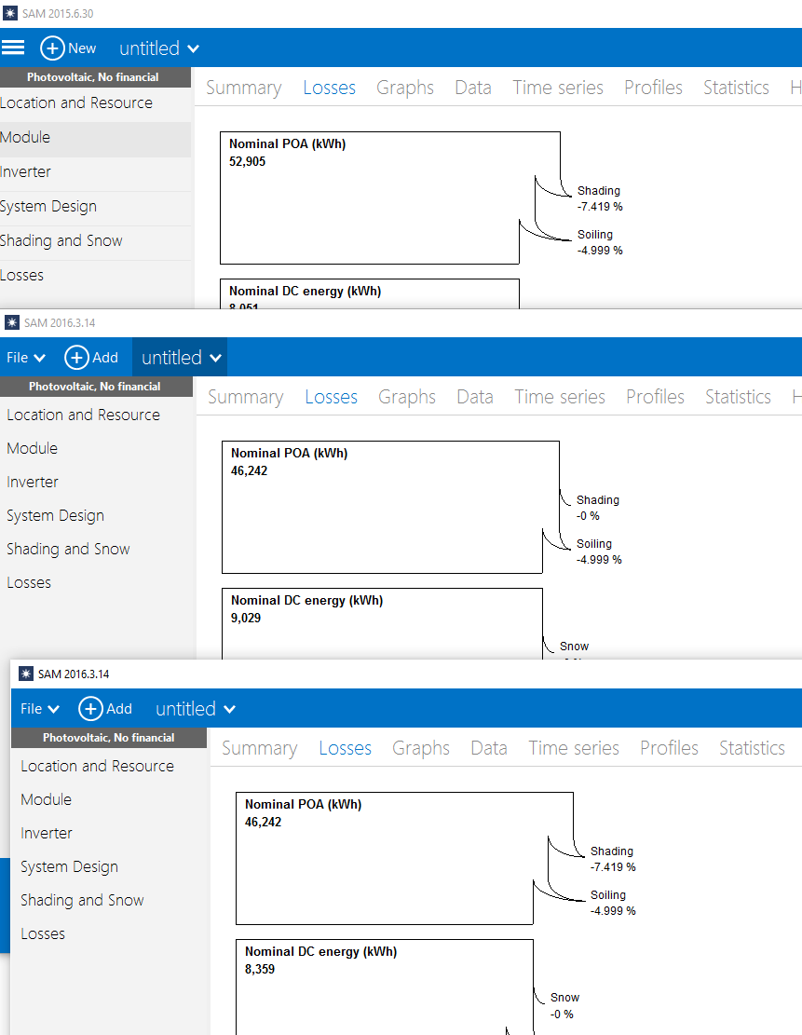

2016.3.14 public release is incorrect – applying loss per shading database to net dc output rather than beam. This is the “string_option” variable incorrectly passed as 0 (shading database) whenever a shading input method other than timestep enabled. The issue is a bug in the 2016.3.14 public release and has been corrected in the trunk and the 2016.3.14 branch.

The other issue that has been fixed is the parametric input for the shading factors. In the 2016.3.14 release, the parametrics did not show the string options for the time series inputs:

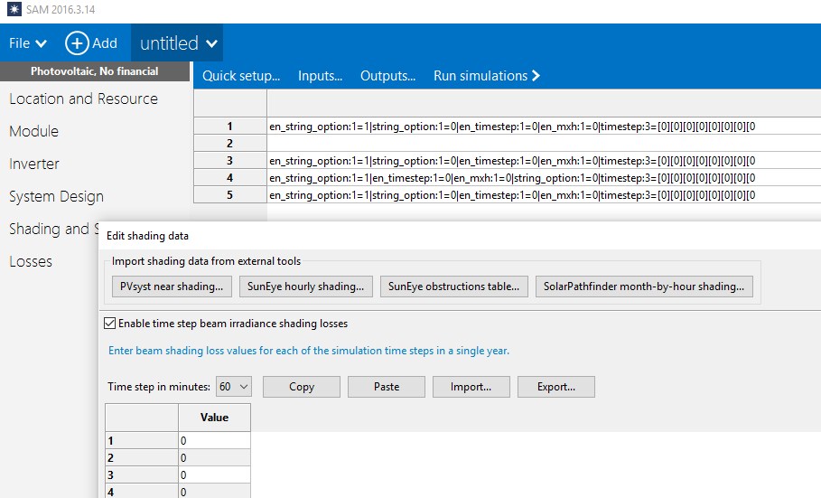

Additional testing with Taran’s obstruction file in the svn version showed that the timestep string options are being applied to the dc net when the shading database option is selected – we can change or discuss further.

This has been updated in the trunk SAMnt rev 2922 and the 2016.3.14 branch SAMnt rev 2923.

Additional clarification needed.

TODO

1. Test all shading configurations
2. Decide whether or not shading database applies to all shading input methods.
3. See about using case configuration instead of form name for parametric display
4. Update loss diagram for dc shading database losses.